Input Image vs Generated Output Images
Numbered Figures, Numbered Tables, Output Descriptions, and All Additional Uploaded Outputs - Updated
Table 1. Source Files Used for the Output Comparison
Source Item | Detected File
Input Image | 1000_500.bmp
Expected Reference | expected_hsv_roundtrip_no_flat_1000_500.bmp
Generated Output Count | 28
Document purpose: Each output page shows the original input image beside one generated output image. The settings table below each figure is decoded directly from that generated output filename, so the documented settings match the image under review.

1. Master Filename-to-Settings Matrix
Table 2. Master Matrix Mapping Each Generated Output Filename to Decoded Settings
# | Generated Output Filename | Mode | USE_FLAT_SEGMENT_PACKAGE | Primary Setting 1 | Primary Setting 2 | Primary Setting 3 | Match Status
1 | FlatSeg_Slt_60_Vdark_40_Vwhite_240_Maj_5_Pass_0.bmp | Flat Segment Package | true | SAT_THRESHOLD_LOW=60 | VALUE_DARK_LIMIT=40 | MAJORITY_PASSES=0 | matched
2 | FlatSeg_Slt_60_Vdark_40_Vwhite_240_Maj_5_Pass_0 - Copy.bmp | Flat Segment Package | true | SAT_THRESHOLD_LOW=60 | VALUE_DARK_LIMIT=40 | MAJORITY_PASSES=0 | matched
3 | FlatSeg_Slt_30_Vdark_40_Vwhite_240_Maj_5_Pass_0.bmp | Flat Segment Package | true | SAT_THRESHOLD_LOW=30 | VALUE_DARK_LIMIT=40 | MAJORITY_PASSES=0 | matched
4 | FlatSeg_Slt_60_Vdark_40_Vwhite_240_Maj_5_Pass_3.bmp | Flat Segment Package | true | SAT_THRESHOLD_LOW=60 | VALUE_DARK_LIMIT=40 | MAJORITY_PASSES=3 | matched
5 | Ho_0_Sgp_125_So_0_Vgp_100_Vo_0_Enf_t_Hs_64_Ss_40_Vs_16_Fcb_t.bmp | RGB-HSV Flat Color | false | HUE_STEP=64 | SATURATION_STEP=40 | VALUE_STEP=16 | matched
6 | Ho_0_Sgp_100_So_0_Vgp_100_Vo_0_Enf_t_Hs_32_Ss_40_Vs_16_Fcb_t.bmp | RGB-HSV Flat Color | false | HUE_STEP=32 | SATURATION_STEP=40 | VALUE_STEP=16 | matched
7 | Ho_0_Sgp_100_So_0_Vgp_100_Vo_0_Enf_t_Hs_40_Ss_40_Vs_16_Fcb_t.bmp | RGB-HSV Flat Color | false | HUE_STEP=40 | SATURATION_STEP=40 | VALUE_STEP=16 | matched
8 | Ho_0_Sgp_100_So_0_Vgp_100_Vo_0_Enf_t_Hs_36_Ss_40_Vs_16_Fcb_t.bmp | RGB-HSV Flat Color | false | HUE_STEP=36 | SATURATION_STEP=40 | VALUE_STEP=16 | matched
9 | Ho_0_Sgp_100_So_0_Vgp_100_Vo_0_Enf_t_Hs_36_Ss_36_Vs_16_Fcb_t.bmp | RGB-HSV Flat Color | false | HUE_STEP=36 | SATURATION_STEP=36 | VALUE_STEP=16 | matched
10 | Ho_0_Sgp_100_So_0_Vgp_100_Vo_0_Enf_t_Hs_36_Ss_8_Vs_16_Fcb_t.bmp | RGB-HSV Flat Color | false | HUE_STEP=36 | SATURATION_STEP=8 | VALUE_STEP=16 | matched
11 | Ho_0_Sgp_100_So_0_Vgp_100_Vo_0_Enf_t_Hs_64_Ss_8_Vs_16_Fcb_t.bmp | RGB-HSV Flat Color | false | HUE_STEP=64 | SATURATION_STEP=8 | VALUE_STEP=16 | matched
12 | Ho_0_Sgp_100_So_0_Vgp_100_Vo_0_Enf_t_Hs_8_Ss_8_Vs_16_Fcb_t.bmp | RGB-HSV Flat Color | false | HUE_STEP=8 | SATURATION_STEP=8 | VALUE_STEP=16 | matched
13 | Ho_0_Sgp_100_So_0_Vgp_100_Vo_0_Enf_t_Hs_16_Ss_8_Vs_16_Fcb_t.bmp | RGB-HSV Flat Color | false | HUE_STEP=16 | SATURATION_STEP=8 | VALUE_STEP=16 | matched
14 | Ho_0_Sgp_100_So_0_Vgp_100_Vo_0_Enf_t_Hs_16_Ss_8_Vs_64_Fcb_t.bmp | RGB-HSV Flat Color | false | HUE_STEP=16 | SATURATION_STEP=8 | VALUE_STEP=64 | matched
15 | Ho_0_Sgp_100_So_0_Vgp_100_Vo_0_Enf_t_Hs_36_Ss_36_Vs_64_Fcb_t.bmp | RGB-HSV Flat Color | false | HUE_STEP=36 | SATURATION_STEP=36 | VALUE_STEP=64 | matched
16 | Ho_0_Sgp_100_So_0_Vgp_100_Vo_0_Enf_t_Hs_64_Ss_64_Vs_64_Fcb_t.bmp | RGB-HSV Flat Color | false | HUE_STEP=64 | SATURATION_STEP=64 | VALUE_STEP=64 | matched
17 | Ho_0_Sgp_100_So_0_Vgp_100_Vo_0_Enf_t_Hs_64_Ss_8_Vs_64_Fcb_t.bmp | RGB-HSV Flat Color | false | HUE_STEP=64 | SATURATION_STEP=8 | VALUE_STEP=64 | matched
18 | Ho_0_Sgp_100_So_0_Vgp_100_Vo_0_Enf_t_Hs_64_Ss_64_Vs_8_Fcb_t.bmp | RGB-HSV Flat Color | false | HUE_STEP=64 | SATURATION_STEP=64 | VALUE_STEP=8 | matched
19 | Ho_0_Sgp_100_So_0_Vgp_100_Vo_0_Enf_t_Hs_16_Ss_128_Vs_128_Fcb_t.bmp | RGB-HSV Flat Color | false | HUE_STEP=16 | SATURATION_STEP=128 | VALUE_STEP=128 | matched
20 | Ho_0_Sgp_100_So_0_Vgp_100_Vo_0_Enf_t_Hs_32_Ss_64_Vs_85_Fcb_t.bmp | RGB-HSV Flat Color | false | HUE_STEP=32 | SATURATION_STEP=64 | VALUE_STEP=85 | matched
21 | Ho_0_Sgp_100_So_0_Vgp_100_Vo_0_Enf_t_Hs_32_Ss_128_Vs_128_Fcb_t.bmp | RGB-HSV Flat Color | false | HUE_STEP=32 | SATURATION_STEP=128 | VALUE_STEP=128 | matched
22 | Ho_0_Sgp_100_So_0_Vgp_100_Vo_0_Enf_t_Hs_64_Ss_128_Vs_128_Fcb_t.bmp | RGB-HSV Flat Color | false | HUE_STEP=64 | SATURATION_STEP=128 | VALUE_STEP=128 | matched
23 | Ho_0_Sgp_100_So_0_Vgp_100_Vo_0_Enf_t_Hs_32_Ss_85_Vs_128_Fcb_t.bmp | RGB-HSV Flat Color | false | HUE_STEP=32 | SATURATION_STEP=85 | VALUE_STEP=128 | matched
24 | Ho_0_Sgp_100_So_0_Vgp_100_Vo_0_Enf_t_Hs_32_Ss_42_Vs_128_Fcb_t.bmp | RGB-HSV Flat Color | false | HUE_STEP=32 | SATURATION_STEP=42 | VALUE_STEP=128 | matched
25 | Ho_0_Sgp_100_So_0_Vgp_100_Vo_0_Enf_t_Hs_32_Ss_85_Vs_85_Fcb_t.bmp | RGB-HSV Flat Color | false | HUE_STEP=32 | SATURATION_STEP=85 | VALUE_STEP=85 | matched
26 | Ho_0_Sgp_100_So_0_Vgp_100_Vo_0_Enf_t_Hs_32_Ss_85_Vs_120_Fcb_t.bmp | RGB-HSV Flat Color | false | HUE_STEP=32 | SATURATION_STEP=85 | VALUE_STEP=120 | matched
27 | Ho_0_Sgp_100_So_0_Vgp_100_Vo_0_Enf_t_Hs_32_Ss_120_Vs_43_Fcb_t.bmp | RGB-HSV Flat Color | false | HUE_STEP=32 | SATURATION_STEP=120 | VALUE_STEP=43 | matched
28 | Ho_0_Sgp_100_So_0_Vgp_100_Vo_0_Enf_t_Hs_32_Ss_120_Vs_85_Fcb_t.bmp | RGB-HSV Flat Color | false | HUE_STEP=32 | SATURATION_STEP=120 | VALUE_STEP=85 | matched

2. Filename Token Legend
Table 3. Filename Tokens and Corresponding VHDL Testbench Settings
Filename Token | VHDL Generic / Setting | Meaning
Slt | FLAT_SEGMENT_SAT_THRESHOLD_LOW | Low saturation threshold for flat-segment classification
Vdark | FLAT_SEGMENT_VALUE_DARK_LIMIT | Brightness/value level below which pixels are treated as dark
Vwhite | FLAT_SEGMENT_VALUE_WHITE_LIMIT | Brightness/value level above which low-saturation pixels are treated as white/light
Maj | FLAT_SEGMENT_MAJORITY_MIN_COUNT | Minimum 3x3 neighbor count required for majority cleanup
Pass | FLAT_SEGMENT_MAJORITY_PASSES | Number of majority-cleanup passes
Ho | RGB_HSV_HUE_OFFSET | Hue offset applied in the RGB-HSV testbench path
Sgp | RGB_HSV_SATURATION_GAIN_PERCENT | Saturation gain percentage
So | RGB_HSV_SATURATION_OFFSET | Saturation offset
Vgp | RGB_HSV_VALUE_GAIN_PERCENT | Value/brightness gain percentage
Vo | RGB_HSV_VALUE_OFFSET | Value/brightness offset
Enf | RGB_HSV_ENABLE_FLAT_COLOR | Enable flat-color binning in HSV path
Hs | RGB_HSV_HUE_STEP | Hue quantization step
Ss | RGB_HSV_SATURATION_STEP | Saturation quantization step
Vs | RGB_HSV_VALUE_STEP | Value quantization step
Fcb | RGB_HSV_FLAT_CENTER_BINS | Center flat-color bins instead of using lower-bin edge

3.1 Output 1: Side-by-Side Visual Comparison
Generated Output Filename: FlatSeg_Slt_60_Vdark_40_Vwhite_240_Maj_5_Pass_0.bmp | Mode: Flat Segment Package
Figure 1. Input Image Compared with Generated Output 1
Input Image | Generated Output Image
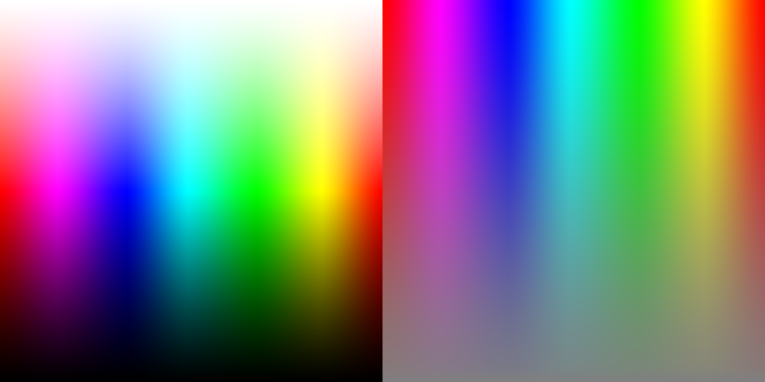  1000_500.bmp | 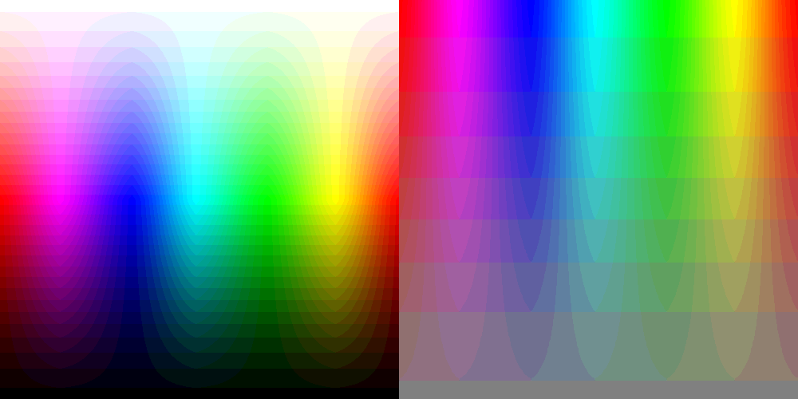  FlatSeg_Slt_60_Vdark_40_Vwhite_240_Maj_5_Pass_0.bmp
Output description: This output uses the flat-segment package path. The saturation threshold is 60, so low-saturation pixels are separated from stronger color regions before value limits are applied. Pixels below value 40 are treated as dark-region candidates, while low-saturation pixels above value 240 are treated as light/white-region candidates. The majority filter requires 5 agreeing samples in the 3x3 neighborhood and applies no majority-cleanup smoothing. The visual result should preserve the input structure while reducing fine color variation into flatter regions.
Table 4. Settings Decoded from Generated Output 1 Filename
Setting | Data Type | Value Matched from Filename | Filename Token / Source
USE_FLAT_SEGMENT_PACKAGE | boolean | true | file prefix FlatSeg
FLAT_SEGMENT_SAT_THRESHOLD_LOW | integer | 60 | Slt
FLAT_SEGMENT_VALUE_DARK_LIMIT | integer | 40 | Vdark
FLAT_SEGMENT_VALUE_WHITE_LIMIT | integer | 240 | Vwhite
FLAT_SEGMENT_MAJORITY_MIN_COUNT | integer | 5 | Maj
FLAT_SEGMENT_MAJORITY_PASSES | integer | 0 | Pass

3.2 Output 2: Side-by-Side Visual Comparison
Generated Output Filename: FlatSeg_Slt_60_Vdark_40_Vwhite_240_Maj_5_Pass_0 - Copy.bmp | Mode: Flat Segment Package
Figure 2. Input Image Compared with Generated Output 2
Input Image | Generated Output Image
  1000_500.bmp |   FlatSeg_Slt_60_Vdark_40_Vwhite_240_Maj_5_Pass_0 - Copy.bmp
Output description: This output uses the flat-segment package path. The saturation threshold is 60, so low-saturation pixels are separated from stronger color regions before value limits are applied. Pixels below value 40 are treated as dark-region candidates, while low-saturation pixels above value 240 are treated as light/white-region candidates. The majority filter requires 5 agreeing samples in the 3x3 neighborhood and applies no majority-cleanup smoothing. The visual result should preserve the input structure while reducing fine color variation into flatter regions.
Table 5. Settings Decoded from Generated Output 2 Filename
Setting | Data Type | Value Matched from Filename | Filename Token / Source
USE_FLAT_SEGMENT_PACKAGE | boolean | true | file prefix FlatSeg
FLAT_SEGMENT_SAT_THRESHOLD_LOW | integer | 60 | Slt
FLAT_SEGMENT_VALUE_DARK_LIMIT | integer | 40 | Vdark
FLAT_SEGMENT_VALUE_WHITE_LIMIT | integer | 240 | Vwhite
FLAT_SEGMENT_MAJORITY_MIN_COUNT | integer | 5 | Maj
FLAT_SEGMENT_MAJORITY_PASSES | integer | 0 | Pass

3.3 Output 3: Side-by-Side Visual Comparison
Generated Output Filename: FlatSeg_Slt_30_Vdark_40_Vwhite_240_Maj_5_Pass_0.bmp | Mode: Flat Segment Package
Figure 3. Input Image Compared with Generated Output 3
Input Image | Generated Output Image
  1000_500.bmp |   FlatSeg_Slt_30_Vdark_40_Vwhite_240_Maj_5_Pass_0.bmp
Output description: This output uses the flat-segment package path. The saturation threshold is 30, so low-saturation pixels are separated from stronger color regions before value limits are applied. Pixels below value 40 are treated as dark-region candidates, while low-saturation pixels above value 240 are treated as light/white-region candidates. The majority filter requires 5 agreeing samples in the 3x3 neighborhood and applies no majority-cleanup smoothing. The visual result should preserve the input structure while reducing fine color variation into flatter regions.
Table 6. Settings Decoded from Generated Output 3 Filename
Setting | Data Type | Value Matched from Filename | Filename Token / Source
USE_FLAT_SEGMENT_PACKAGE | boolean | true | file prefix FlatSeg
FLAT_SEGMENT_SAT_THRESHOLD_LOW | integer | 30 | Slt
FLAT_SEGMENT_VALUE_DARK_LIMIT | integer | 40 | Vdark
FLAT_SEGMENT_VALUE_WHITE_LIMIT | integer | 240 | Vwhite
FLAT_SEGMENT_MAJORITY_MIN_COUNT | integer | 5 | Maj
FLAT_SEGMENT_MAJORITY_PASSES | integer | 0 | Pass

3.4 Output 4: Side-by-Side Visual Comparison
Generated Output Filename: FlatSeg_Slt_60_Vdark_40_Vwhite_240_Maj_5_Pass_3.bmp | Mode: Flat Segment Package
Figure 4. Input Image Compared with Generated Output 4
Input Image | Generated Output Image
  1000_500.bmp | 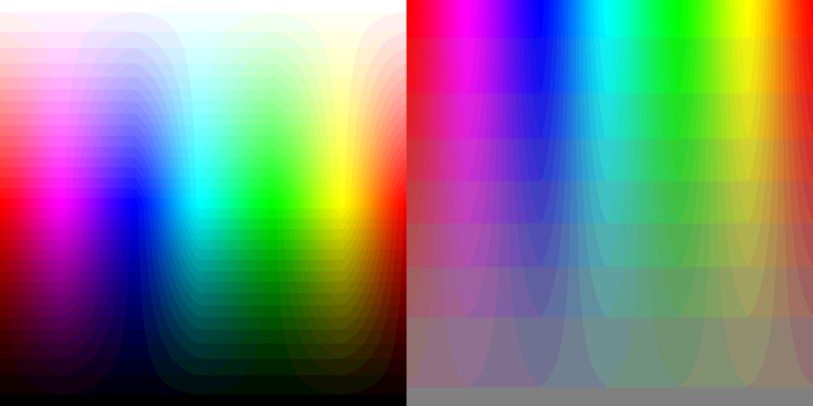  FlatSeg_Slt_60_Vdark_40_Vwhite_240_Maj_5_Pass_3.bmp
Output description: This output uses the flat-segment package path. The saturation threshold is 60, so low-saturation pixels are separated from stronger color regions before value limits are applied. Pixels below value 40 are treated as dark-region candidates, while low-saturation pixels above value 240 are treated as light/white-region candidates. The majority filter requires 5 agreeing samples in the 3x3 neighborhood and applies 3 majority-cleanup pass(es). The visual result should preserve the input structure while reducing fine color variation into flatter regions.
Table 7. Settings Decoded from Generated Output 4 Filename
Setting | Data Type | Value Matched from Filename | Filename Token / Source
USE_FLAT_SEGMENT_PACKAGE | boolean | true | file prefix FlatSeg
FLAT_SEGMENT_SAT_THRESHOLD_LOW | integer | 60 | Slt
FLAT_SEGMENT_VALUE_DARK_LIMIT | integer | 40 | Vdark
FLAT_SEGMENT_VALUE_WHITE_LIMIT | integer | 240 | Vwhite
FLAT_SEGMENT_MAJORITY_MIN_COUNT | integer | 5 | Maj
FLAT_SEGMENT_MAJORITY_PASSES | integer | 3 | Pass

3.5 Output 5: Side-by-Side Visual Comparison
Generated Output Filename: Ho_0_Sgp_125_So_0_Vgp_100_Vo_0_Enf_t_Hs_64_Ss_40_Vs_16_Fcb_t.bmp | Mode: RGB-HSV Flat Color
Figure 5. Input Image Compared with Generated Output 5
Input Image | Generated Output Image
  1000_500.bmp | 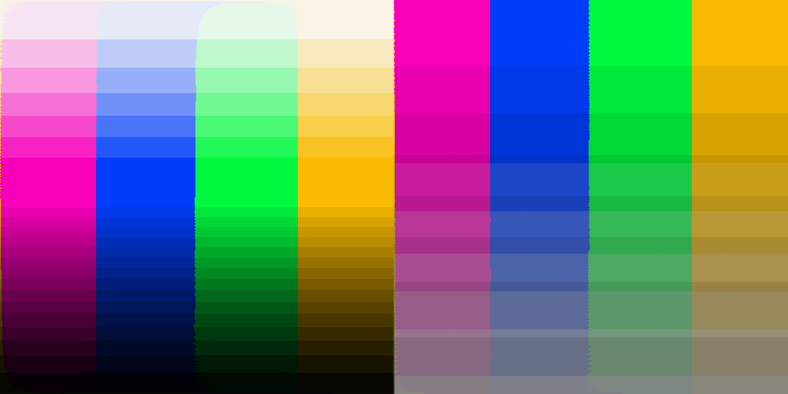  Ho_0_Sgp_125_So_0_Vgp_100_Vo_0_Enf_t_Hs_64_Ss_40_Vs_16_Fcb_t.bmp
Output description: This output uses the RGB-to-HSV flat-color path with flat-color enable set to true. Hue is quantized with step 64, saturation with step 40, and value/brightness with step 16. Flat-center binning is true, so each quantized bin is represented by its centered value when enabled. The visual result converts smooth gradients into discrete HSV color bands; larger steps create larger, flatter blocks, while smaller steps preserve more tonal detail.
Table 8. Settings Decoded from Generated Output 5 Filename
Setting | Data Type | Value Matched from Filename | Filename Token / Source
USE_FLAT_SEGMENT_PACKAGE | boolean | false | file prefix Ho
RGB_HSV_HUE_OFFSET | integer | false | Ho
RGB_HSV_SATURATION_GAIN_PERCENT | integer | 125 | Sgp
RGB_HSV_SATURATION_OFFSET | integer | false | So
RGB_HSV_VALUE_GAIN_PERCENT | integer | 100 | Vgp
RGB_HSV_VALUE_OFFSET | integer | false | Vo
RGB_HSV_ENABLE_FLAT_COLOR | boolean | true | Enf
RGB_HSV_HUE_STEP | integer | 64 | Hs
RGB_HSV_SATURATION_STEP | integer | 40 | Ss
RGB_HSV_VALUE_STEP | integer | 16 | Vs
RGB_HSV_FLAT_CENTER_BINS | boolean | true | Fcb

3.6 Output 6: Side-by-Side Visual Comparison
Generated Output Filename: Ho_0_Sgp_100_So_0_Vgp_100_Vo_0_Enf_t_Hs_32_Ss_40_Vs_16_Fcb_t.bmp | Mode: RGB-HSV Flat Color
Figure 6. Input Image Compared with Generated Output 6
Input Image | Generated Output Image
  1000_500.bmp | 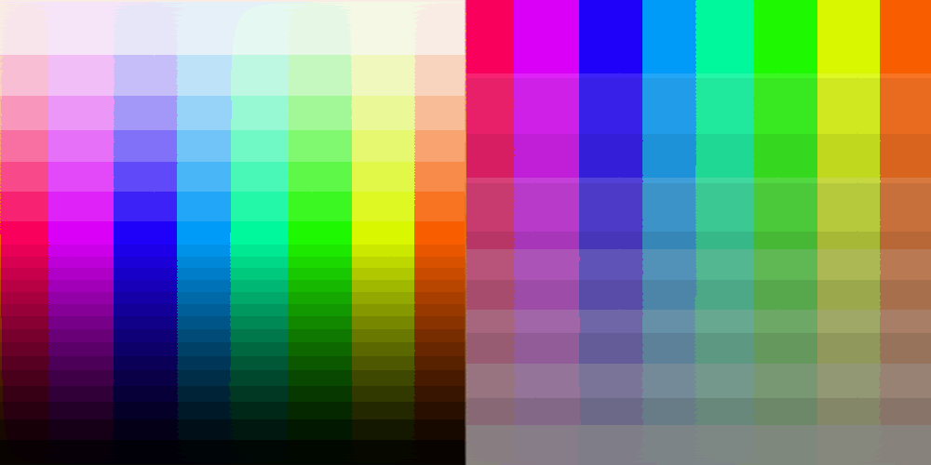  Ho_0_Sgp_100_So_0_Vgp_100_Vo_0_Enf_t_Hs_32_Ss_40_Vs_16_Fcb_t.bmp
Output description: This output uses the RGB-to-HSV flat-color path with flat-color enable set to true. Hue is quantized with step 32, saturation with step 40, and value/brightness with step 16. Flat-center binning is true, so each quantized bin is represented by its centered value when enabled. The visual result converts smooth gradients into discrete HSV color bands; larger steps create larger, flatter blocks, while smaller steps preserve more tonal detail.
Table 9. Settings Decoded from Generated Output 6 Filename
Setting | Data Type | Value Matched from Filename | Filename Token / Source
USE_FLAT_SEGMENT_PACKAGE | boolean | false | file prefix Ho
RGB_HSV_HUE_OFFSET | integer | false | Ho
RGB_HSV_SATURATION_GAIN_PERCENT | integer | 100 | Sgp
RGB_HSV_SATURATION_OFFSET | integer | false | So
RGB_HSV_VALUE_GAIN_PERCENT | integer | 100 | Vgp
RGB_HSV_VALUE_OFFSET | integer | false | Vo
RGB_HSV_ENABLE_FLAT_COLOR | boolean | true | Enf
RGB_HSV_HUE_STEP | integer | 32 | Hs
RGB_HSV_SATURATION_STEP | integer | 40 | Ss
RGB_HSV_VALUE_STEP | integer | 16 | Vs
RGB_HSV_FLAT_CENTER_BINS | boolean | true | Fcb

3.7 Output 7: Side-by-Side Visual Comparison
Generated Output Filename: Ho_0_Sgp_100_So_0_Vgp_100_Vo_0_Enf_t_Hs_40_Ss_40_Vs_16_Fcb_t.bmp | Mode: RGB-HSV Flat Color
Figure 7. Input Image Compared with Generated Output 7
Input Image | Generated Output Image
  1000_500.bmp | 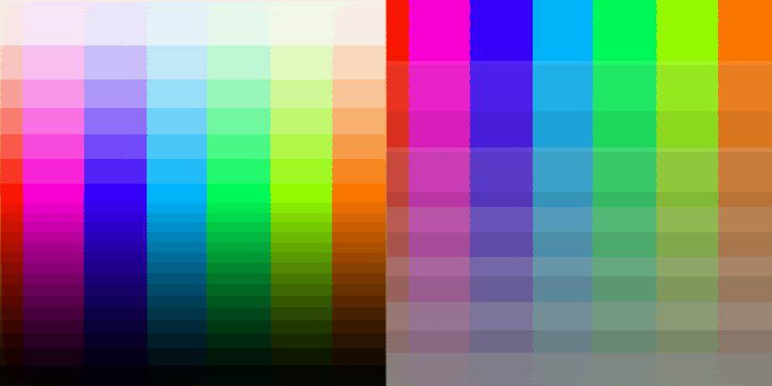  Ho_0_Sgp_100_So_0_Vgp_100_Vo_0_Enf_t_Hs_40_Ss_40_Vs_16_Fcb_t.bmp
Output description: This output uses the RGB-to-HSV flat-color path with flat-color enable set to true. Hue is quantized with step 40, saturation with step 40, and value/brightness with step 16. Flat-center binning is true, so each quantized bin is represented by its centered value when enabled. The visual result converts smooth gradients into discrete HSV color bands; larger steps create larger, flatter blocks, while smaller steps preserve more tonal detail.
Table 10. Settings Decoded from Generated Output 7 Filename
Setting | Data Type | Value Matched from Filename | Filename Token / Source
USE_FLAT_SEGMENT_PACKAGE | boolean | false | file prefix Ho
RGB_HSV_HUE_OFFSET | integer | false | Ho
RGB_HSV_SATURATION_GAIN_PERCENT | integer | 100 | Sgp
RGB_HSV_SATURATION_OFFSET | integer | false | So
RGB_HSV_VALUE_GAIN_PERCENT | integer | 100 | Vgp
RGB_HSV_VALUE_OFFSET | integer | false | Vo
RGB_HSV_ENABLE_FLAT_COLOR | boolean | true | Enf
RGB_HSV_HUE_STEP | integer | 40 | Hs
RGB_HSV_SATURATION_STEP | integer | 40 | Ss
RGB_HSV_VALUE_STEP | integer | 16 | Vs
RGB_HSV_FLAT_CENTER_BINS | boolean | true | Fcb

3.8 Output 8: Side-by-Side Visual Comparison
Generated Output Filename: Ho_0_Sgp_100_So_0_Vgp_100_Vo_0_Enf_t_Hs_36_Ss_40_Vs_16_Fcb_t.bmp | Mode: RGB-HSV Flat Color
Figure 8. Input Image Compared with Generated Output 8
Input Image | Generated Output Image
  1000_500.bmp | 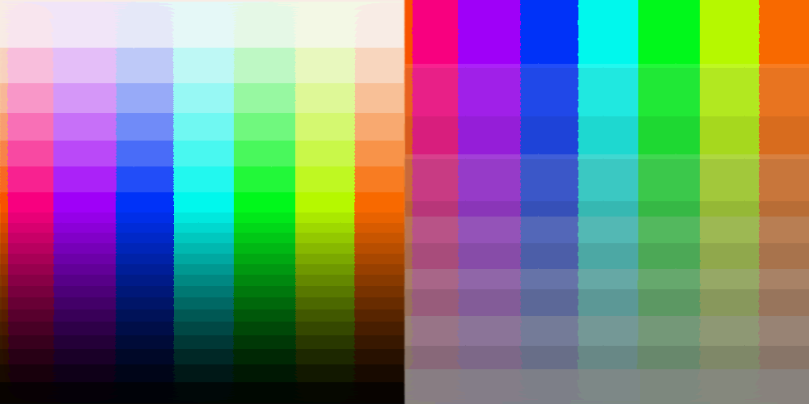  Ho_0_Sgp_100_So_0_Vgp_100_Vo_0_Enf_t_Hs_36_Ss_40_Vs_16_Fcb_t.bmp
Output description: This output uses the RGB-to-HSV flat-color path with flat-color enable set to true. Hue is quantized with step 36, saturation with step 40, and value/brightness with step 16. Flat-center binning is true, so each quantized bin is represented by its centered value when enabled. The visual result converts smooth gradients into discrete HSV color bands; larger steps create larger, flatter blocks, while smaller steps preserve more tonal detail.
Table 11. Settings Decoded from Generated Output 8 Filename
Setting | Data Type | Value Matched from Filename | Filename Token / Source
USE_FLAT_SEGMENT_PACKAGE | boolean | false | file prefix Ho
RGB_HSV_HUE_OFFSET | integer | false | Ho
RGB_HSV_SATURATION_GAIN_PERCENT | integer | 100 | Sgp
RGB_HSV_SATURATION_OFFSET | integer | false | So
RGB_HSV_VALUE_GAIN_PERCENT | integer | 100 | Vgp
RGB_HSV_VALUE_OFFSET | integer | false | Vo
RGB_HSV_ENABLE_FLAT_COLOR | boolean | true | Enf
RGB_HSV_HUE_STEP | integer | 36 | Hs
RGB_HSV_SATURATION_STEP | integer | 40 | Ss
RGB_HSV_VALUE_STEP | integer | 16 | Vs
RGB_HSV_FLAT_CENTER_BINS | boolean | true | Fcb

3.9 Output 9: Side-by-Side Visual Comparison
Generated Output Filename: Ho_0_Sgp_100_So_0_Vgp_100_Vo_0_Enf_t_Hs_36_Ss_36_Vs_16_Fcb_t.bmp | Mode: RGB-HSV Flat Color
Figure 9. Input Image Compared with Generated Output 9
Input Image | Generated Output Image
  1000_500.bmp | 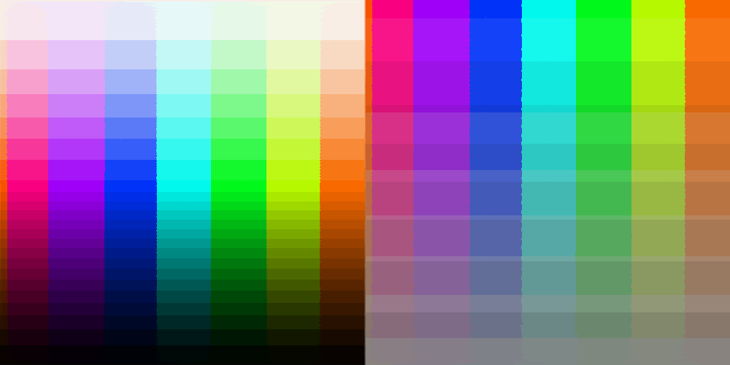  Ho_0_Sgp_100_So_0_Vgp_100_Vo_0_Enf_t_Hs_36_Ss_36_Vs_16_Fcb_t.bmp
Output description: This output uses the RGB-to-HSV flat-color path with flat-color enable set to true. Hue is quantized with step 36, saturation with step 36, and value/brightness with step 16. Flat-center binning is true, so each quantized bin is represented by its centered value when enabled. The visual result converts smooth gradients into discrete HSV color bands; larger steps create larger, flatter blocks, while smaller steps preserve more tonal detail.
Table 12. Settings Decoded from Generated Output 9 Filename
Setting | Data Type | Value Matched from Filename | Filename Token / Source
USE_FLAT_SEGMENT_PACKAGE | boolean | false | file prefix Ho
RGB_HSV_HUE_OFFSET | integer | false | Ho
RGB_HSV_SATURATION_GAIN_PERCENT | integer | 100 | Sgp
RGB_HSV_SATURATION_OFFSET | integer | false | So
RGB_HSV_VALUE_GAIN_PERCENT | integer | 100 | Vgp
RGB_HSV_VALUE_OFFSET | integer | false | Vo
RGB_HSV_ENABLE_FLAT_COLOR | boolean | true | Enf
RGB_HSV_HUE_STEP | integer | 36 | Hs
RGB_HSV_SATURATION_STEP | integer | 36 | Ss
RGB_HSV_VALUE_STEP | integer | 16 | Vs
RGB_HSV_FLAT_CENTER_BINS | boolean | true | Fcb

3.10 Output 10: Side-by-Side Visual Comparison
Generated Output Filename: Ho_0_Sgp_100_So_0_Vgp_100_Vo_0_Enf_t_Hs_36_Ss_8_Vs_16_Fcb_t.bmp | Mode: RGB-HSV Flat Color
Figure 10. Input Image Compared with Generated Output 10
Input Image | Generated Output Image
  1000_500.bmp | 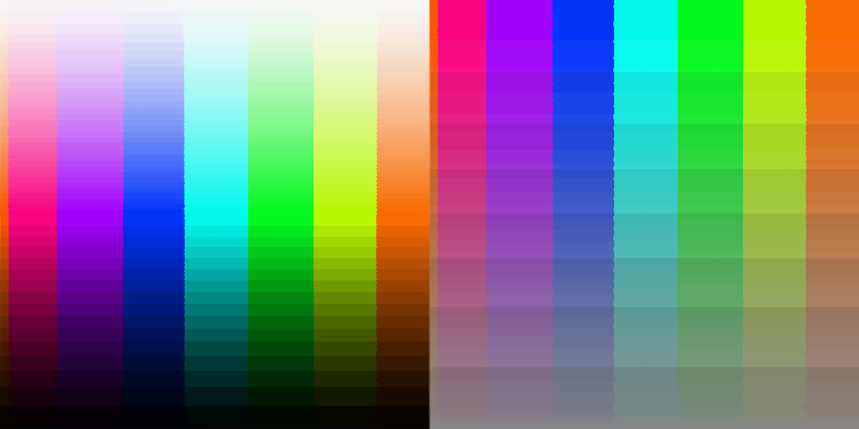  Ho_0_Sgp_100_So_0_Vgp_100_Vo_0_Enf_t_Hs_36_Ss_8_Vs_16_Fcb_t.bmp
Output description: This output uses the RGB-to-HSV flat-color path with flat-color enable set to true. Hue is quantized with step 36, saturation with step 8, and value/brightness with step 16. Flat-center binning is true, so each quantized bin is represented by its centered value when enabled. The visual result converts smooth gradients into discrete HSV color bands; larger steps create larger, flatter blocks, while smaller steps preserve more tonal detail.
Table 13. Settings Decoded from Generated Output 10 Filename
Setting | Data Type | Value Matched from Filename | Filename Token / Source
USE_FLAT_SEGMENT_PACKAGE | boolean | false | file prefix Ho
RGB_HSV_HUE_OFFSET | integer | false | Ho
RGB_HSV_SATURATION_GAIN_PERCENT | integer | 100 | Sgp
RGB_HSV_SATURATION_OFFSET | integer | false | So
RGB_HSV_VALUE_GAIN_PERCENT | integer | 100 | Vgp
RGB_HSV_VALUE_OFFSET | integer | false | Vo
RGB_HSV_ENABLE_FLAT_COLOR | boolean | true | Enf
RGB_HSV_HUE_STEP | integer | 36 | Hs
RGB_HSV_SATURATION_STEP | integer | 8 | Ss
RGB_HSV_VALUE_STEP | integer | 16 | Vs
RGB_HSV_FLAT_CENTER_BINS | boolean | true | Fcb

3.11 Output 11: Side-by-Side Visual Comparison
Generated Output Filename: Ho_0_Sgp_100_So_0_Vgp_100_Vo_0_Enf_t_Hs_64_Ss_8_Vs_16_Fcb_t.bmp | Mode: RGB-HSV Flat Color
Figure 11. Input Image Compared with Generated Output 11
Input Image | Generated Output Image
  1000_500.bmp | 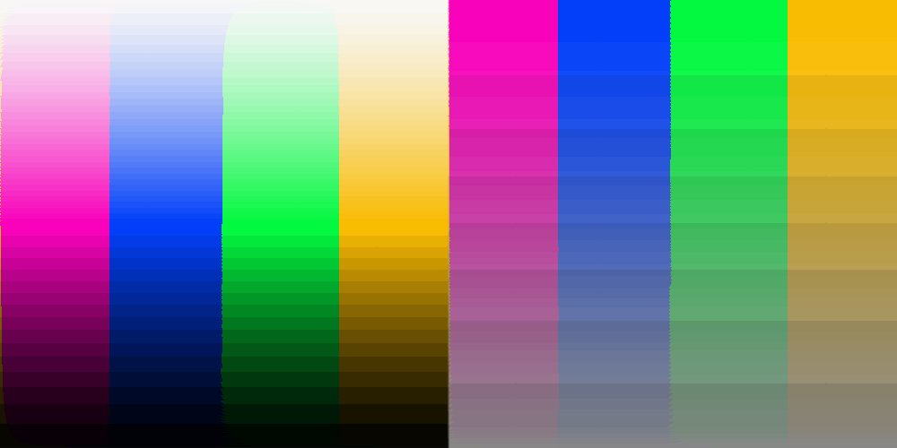  Ho_0_Sgp_100_So_0_Vgp_100_Vo_0_Enf_t_Hs_64_Ss_8_Vs_16_Fcb_t.bmp
Output description: This output uses the RGB-to-HSV flat-color path with flat-color enable set to true. Hue is quantized with step 64, saturation with step 8, and value/brightness with step 16. Flat-center binning is true, so each quantized bin is represented by its centered value when enabled. The visual result converts smooth gradients into discrete HSV color bands; larger steps create larger, flatter blocks, while smaller steps preserve more tonal detail.
Table 14. Settings Decoded from Generated Output 11 Filename
Setting | Data Type | Value Matched from Filename | Filename Token / Source
USE_FLAT_SEGMENT_PACKAGE | boolean | false | file prefix Ho
RGB_HSV_HUE_OFFSET | integer | false | Ho
RGB_HSV_SATURATION_GAIN_PERCENT | integer | 100 | Sgp
RGB_HSV_SATURATION_OFFSET | integer | false | So
RGB_HSV_VALUE_GAIN_PERCENT | integer | 100 | Vgp
RGB_HSV_VALUE_OFFSET | integer | false | Vo
RGB_HSV_ENABLE_FLAT_COLOR | boolean | true | Enf
RGB_HSV_HUE_STEP | integer | 64 | Hs
RGB_HSV_SATURATION_STEP | integer | 8 | Ss
RGB_HSV_VALUE_STEP | integer | 16 | Vs
RGB_HSV_FLAT_CENTER_BINS | boolean | true | Fcb

3.12 Output 12: Side-by-Side Visual Comparison
Generated Output Filename: Ho_0_Sgp_100_So_0_Vgp_100_Vo_0_Enf_t_Hs_8_Ss_8_Vs_16_Fcb_t.bmp | Mode: RGB-HSV Flat Color
Figure 12. Input Image Compared with Generated Output 12
Input Image | Generated Output Image
  1000_500.bmp | 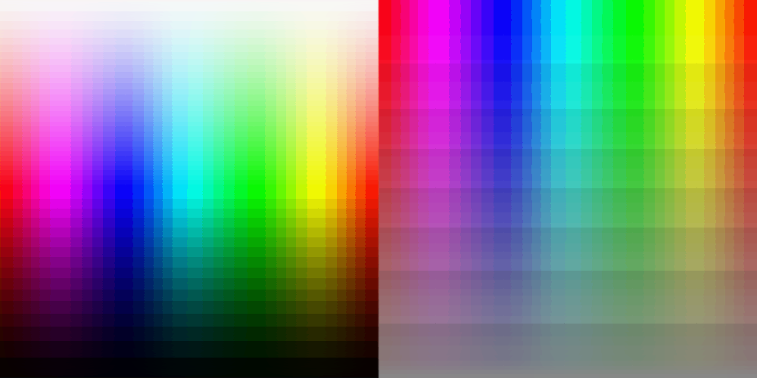  Ho_0_Sgp_100_So_0_Vgp_100_Vo_0_Enf_t_Hs_8_Ss_8_Vs_16_Fcb_t.bmp
Output description: This output uses the RGB-to-HSV flat-color path with flat-color enable set to true. Hue is quantized with step 8, saturation with step 8, and value/brightness with step 16. Flat-center binning is true, so each quantized bin is represented by its centered value when enabled. The visual result converts smooth gradients into discrete HSV color bands; larger steps create larger, flatter blocks, while smaller steps preserve more tonal detail.
Table 15. Settings Decoded from Generated Output 12 Filename
Setting | Data Type | Value Matched from Filename | Filename Token / Source
USE_FLAT_SEGMENT_PACKAGE | boolean | false | file prefix Ho
RGB_HSV_HUE_OFFSET | integer | false | Ho
RGB_HSV_SATURATION_GAIN_PERCENT | integer | 100 | Sgp
RGB_HSV_SATURATION_OFFSET | integer | false | So
RGB_HSV_VALUE_GAIN_PERCENT | integer | 100 | Vgp
RGB_HSV_VALUE_OFFSET | integer | false | Vo
RGB_HSV_ENABLE_FLAT_COLOR | boolean | true | Enf
RGB_HSV_HUE_STEP | integer | 8 | Hs
RGB_HSV_SATURATION_STEP | integer | 8 | Ss
RGB_HSV_VALUE_STEP | integer | 16 | Vs
RGB_HSV_FLAT_CENTER_BINS | boolean | true | Fcb

3.13 Output 13: Side-by-Side Visual Comparison
Generated Output Filename: Ho_0_Sgp_100_So_0_Vgp_100_Vo_0_Enf_t_Hs_16_Ss_8_Vs_16_Fcb_t.bmp | Mode: RGB-HSV Flat Color
Figure 13. Input Image Compared with Generated Output 13
Input Image | Generated Output Image
  1000_500.bmp | 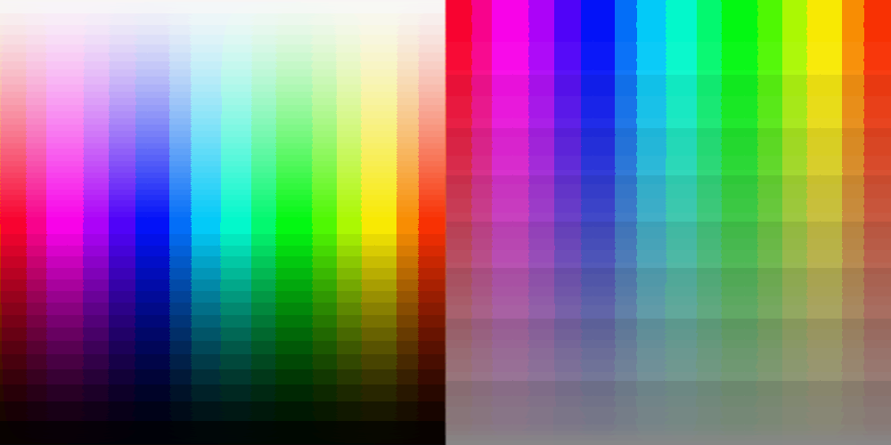  Ho_0_Sgp_100_So_0_Vgp_100_Vo_0_Enf_t_Hs_16_Ss_8_Vs_16_Fcb_t.bmp
Output description: This output uses the RGB-to-HSV flat-color path with flat-color enable set to true. Hue is quantized with step 16, saturation with step 8, and value/brightness with step 16. Flat-center binning is true, so each quantized bin is represented by its centered value when enabled. The visual result converts smooth gradients into discrete HSV color bands; larger steps create larger, flatter blocks, while smaller steps preserve more tonal detail.
Table 16. Settings Decoded from Generated Output 13 Filename
Setting | Data Type | Value Matched from Filename | Filename Token / Source
USE_FLAT_SEGMENT_PACKAGE | boolean | false | file prefix Ho
RGB_HSV_HUE_OFFSET | integer | false | Ho
RGB_HSV_SATURATION_GAIN_PERCENT | integer | 100 | Sgp
RGB_HSV_SATURATION_OFFSET | integer | false | So
RGB_HSV_VALUE_GAIN_PERCENT | integer | 100 | Vgp
RGB_HSV_VALUE_OFFSET | integer | false | Vo
RGB_HSV_ENABLE_FLAT_COLOR | boolean | true | Enf
RGB_HSV_HUE_STEP | integer | 16 | Hs
RGB_HSV_SATURATION_STEP | integer | 8 | Ss
RGB_HSV_VALUE_STEP | integer | 16 | Vs
RGB_HSV_FLAT_CENTER_BINS | boolean | true | Fcb

3.14 Output 14: Side-by-Side Visual Comparison
Generated Output Filename: Ho_0_Sgp_100_So_0_Vgp_100_Vo_0_Enf_t_Hs_16_Ss_8_Vs_64_Fcb_t.bmp | Mode: RGB-HSV Flat Color
Figure 14. Input Image Compared with Generated Output 14
Input Image | Generated Output Image
  1000_500.bmp | 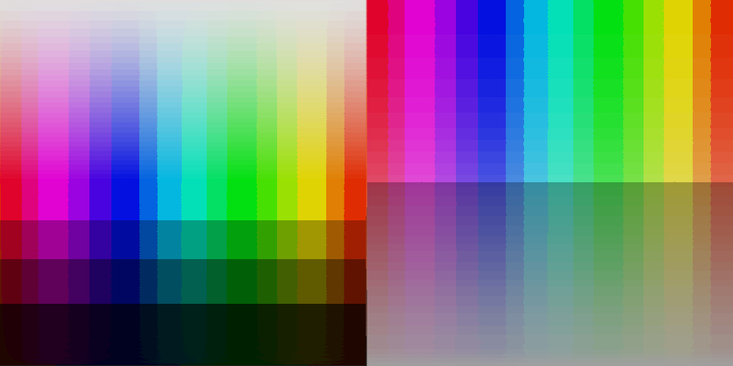  Ho_0_Sgp_100_So_0_Vgp_100_Vo_0_Enf_t_Hs_16_Ss_8_Vs_64_Fcb_t.bmp
Output description: This output uses the RGB-to-HSV flat-color path with flat-color enable set to true. Hue is quantized with step 16, saturation with step 8, and value/brightness with step 64. Flat-center binning is true, so each quantized bin is represented by its centered value when enabled. The visual result converts smooth gradients into discrete HSV color bands; larger steps create larger, flatter blocks, while smaller steps preserve more tonal detail.
Table 17. Settings Decoded from Generated Output 14 Filename
Setting | Data Type | Value Matched from Filename | Filename Token / Source
USE_FLAT_SEGMENT_PACKAGE | boolean | false | file prefix Ho
RGB_HSV_HUE_OFFSET | integer | false | Ho
RGB_HSV_SATURATION_GAIN_PERCENT | integer | 100 | Sgp
RGB_HSV_SATURATION_OFFSET | integer | false | So
RGB_HSV_VALUE_GAIN_PERCENT | integer | 100 | Vgp
RGB_HSV_VALUE_OFFSET | integer | false | Vo
RGB_HSV_ENABLE_FLAT_COLOR | boolean | true | Enf
RGB_HSV_HUE_STEP | integer | 16 | Hs
RGB_HSV_SATURATION_STEP | integer | 8 | Ss
RGB_HSV_VALUE_STEP | integer | 64 | Vs
RGB_HSV_FLAT_CENTER_BINS | boolean | true | Fcb

3.15 Output 15: Side-by-Side Visual Comparison
Generated Output Filename: Ho_0_Sgp_100_So_0_Vgp_100_Vo_0_Enf_t_Hs_36_Ss_36_Vs_64_Fcb_t.bmp | Mode: RGB-HSV Flat Color
Figure 15. Input Image Compared with Generated Output 15
Input Image | Generated Output Image
  1000_500.bmp | 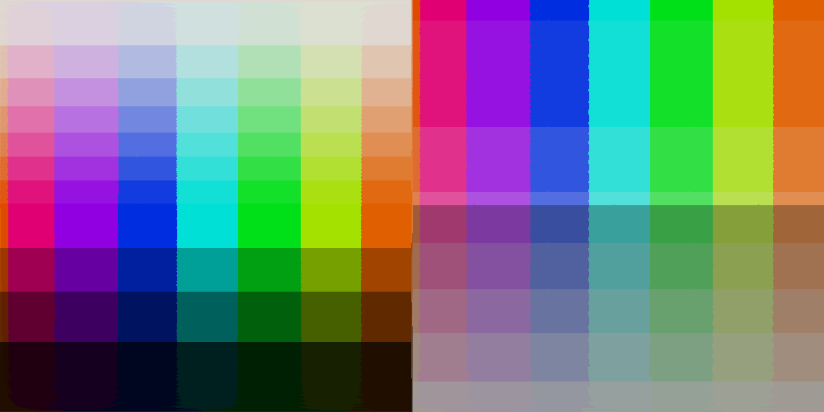  Ho_0_Sgp_100_So_0_Vgp_100_Vo_0_Enf_t_Hs_36_Ss_36_Vs_64_Fcb_t.bmp
Output description: This output uses the RGB-to-HSV flat-color path with flat-color enable set to true. Hue is quantized with step 36, saturation with step 36, and value/brightness with step 64. Flat-center binning is true, so each quantized bin is represented by its centered value when enabled. The visual result converts smooth gradients into discrete HSV color bands; larger steps create larger, flatter blocks, while smaller steps preserve more tonal detail.
Table 18. Settings Decoded from Generated Output 15 Filename
Setting | Data Type | Value Matched from Filename | Filename Token / Source
USE_FLAT_SEGMENT_PACKAGE | boolean | false | file prefix Ho
RGB_HSV_HUE_OFFSET | integer | false | Ho
RGB_HSV_SATURATION_GAIN_PERCENT | integer | 100 | Sgp
RGB_HSV_SATURATION_OFFSET | integer | false | So
RGB_HSV_VALUE_GAIN_PERCENT | integer | 100 | Vgp
RGB_HSV_VALUE_OFFSET | integer | false | Vo
RGB_HSV_ENABLE_FLAT_COLOR | boolean | true | Enf
RGB_HSV_HUE_STEP | integer | 36 | Hs
RGB_HSV_SATURATION_STEP | integer | 36 | Ss
RGB_HSV_VALUE_STEP | integer | 64 | Vs
RGB_HSV_FLAT_CENTER_BINS | boolean | true | Fcb

3.16 Output 16: Side-by-Side Visual Comparison
Generated Output Filename: Ho_0_Sgp_100_So_0_Vgp_100_Vo_0_Enf_t_Hs_64_Ss_64_Vs_64_Fcb_t.bmp | Mode: RGB-HSV Flat Color
Figure 16. Input Image Compared with Generated Output 16
Input Image | Generated Output Image
  1000_500.bmp | 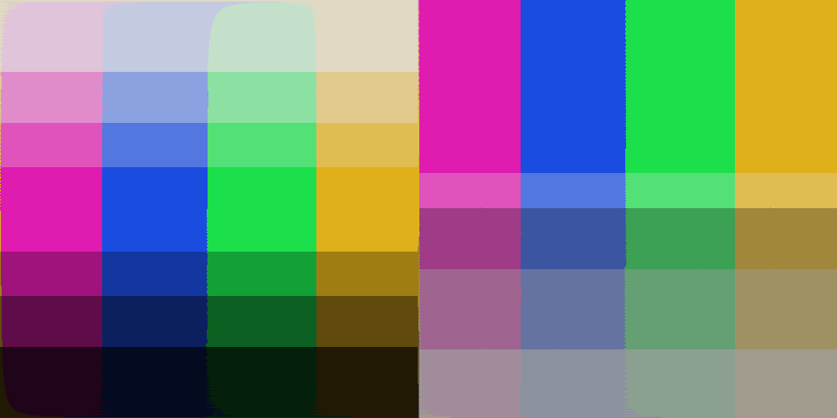  Ho_0_Sgp_100_So_0_Vgp_100_Vo_0_Enf_t_Hs_64_Ss_64_Vs_64_Fcb_t.bmp
Output description: This output uses the RGB-to-HSV flat-color path with flat-color enable set to true. Hue is quantized with step 64, saturation with step 64, and value/brightness with step 64. Flat-center binning is true, so each quantized bin is represented by its centered value when enabled. The visual result converts smooth gradients into discrete HSV color bands; larger steps create larger, flatter blocks, while smaller steps preserve more tonal detail.
Table 19. Settings Decoded from Generated Output 16 Filename
Setting | Data Type | Value Matched from Filename | Filename Token / Source
USE_FLAT_SEGMENT_PACKAGE | boolean | false | file prefix Ho
RGB_HSV_HUE_OFFSET | integer | false | Ho
RGB_HSV_SATURATION_GAIN_PERCENT | integer | 100 | Sgp
RGB_HSV_SATURATION_OFFSET | integer | false | So
RGB_HSV_VALUE_GAIN_PERCENT | integer | 100 | Vgp
RGB_HSV_VALUE_OFFSET | integer | false | Vo
RGB_HSV_ENABLE_FLAT_COLOR | boolean | true | Enf
RGB_HSV_HUE_STEP | integer | 64 | Hs
RGB_HSV_SATURATION_STEP | integer | 64 | Ss
RGB_HSV_VALUE_STEP | integer | 64 | Vs
RGB_HSV_FLAT_CENTER_BINS | boolean | true | Fcb

3.17 Output 17: Side-by-Side Visual Comparison
Generated Output Filename: Ho_0_Sgp_100_So_0_Vgp_100_Vo_0_Enf_t_Hs_64_Ss_8_Vs_64_Fcb_t.bmp | Mode: RGB-HSV Flat Color
Figure 17. Input Image Compared with Generated Output 17
Input Image | Generated Output Image
  1000_500.bmp | 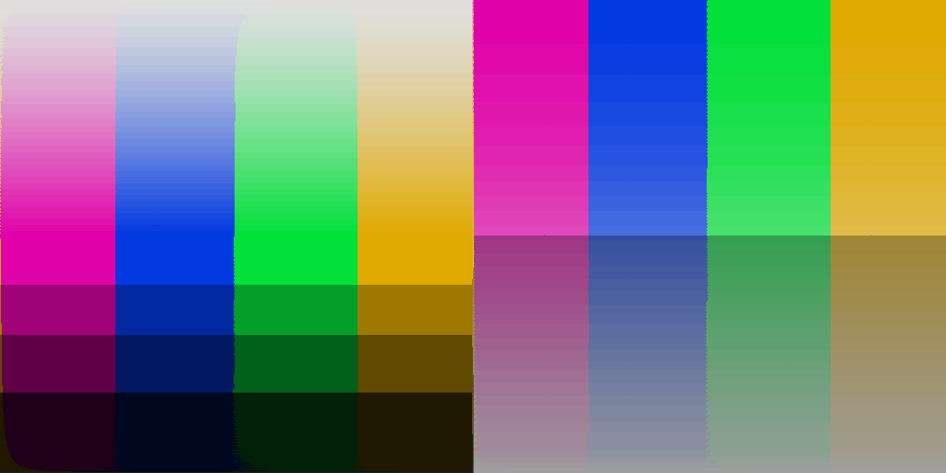  Ho_0_Sgp_100_So_0_Vgp_100_Vo_0_Enf_t_Hs_64_Ss_8_Vs_64_Fcb_t.bmp
Output description: This output uses the RGB-to-HSV flat-color path with flat-color enable set to true. Hue is quantized with step 64, saturation with step 8, and value/brightness with step 64. Flat-center binning is true, so each quantized bin is represented by its centered value when enabled. The visual result converts smooth gradients into discrete HSV color bands; larger steps create larger, flatter blocks, while smaller steps preserve more tonal detail.
Table 20. Settings Decoded from Generated Output 17 Filename
Setting | Data Type | Value Matched from Filename | Filename Token / Source
USE_FLAT_SEGMENT_PACKAGE | boolean | false | file prefix Ho
RGB_HSV_HUE_OFFSET | integer | false | Ho
RGB_HSV_SATURATION_GAIN_PERCENT | integer | 100 | Sgp
RGB_HSV_SATURATION_OFFSET | integer | false | So
RGB_HSV_VALUE_GAIN_PERCENT | integer | 100 | Vgp
RGB_HSV_VALUE_OFFSET | integer | false | Vo
RGB_HSV_ENABLE_FLAT_COLOR | boolean | true | Enf
RGB_HSV_HUE_STEP | integer | 64 | Hs
RGB_HSV_SATURATION_STEP | integer | 8 | Ss
RGB_HSV_VALUE_STEP | integer | 64 | Vs
RGB_HSV_FLAT_CENTER_BINS | boolean | true | Fcb

3.18 Output 18: Side-by-Side Visual Comparison
Generated Output Filename: Ho_0_Sgp_100_So_0_Vgp_100_Vo_0_Enf_t_Hs_64_Ss_64_Vs_8_Fcb_t.bmp | Mode: RGB-HSV Flat Color
Figure 18. Input Image Compared with Generated Output 18
Input Image | Generated Output Image
  1000_500.bmp | 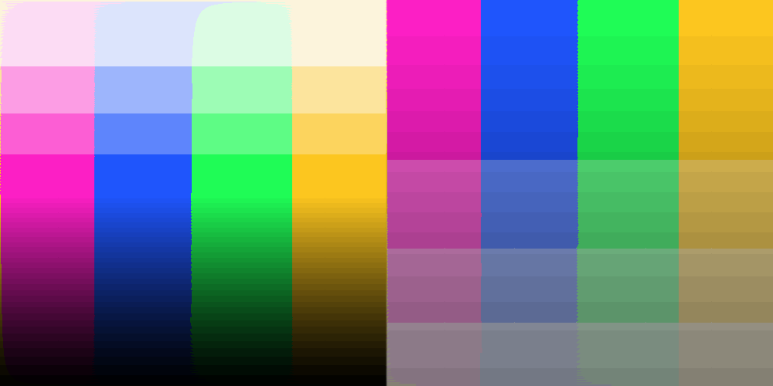  Ho_0_Sgp_100_So_0_Vgp_100_Vo_0_Enf_t_Hs_64_Ss_64_Vs_8_Fcb_t.bmp
Output description: This output uses the RGB-to-HSV flat-color path with flat-color enable set to true. Hue is quantized with step 64, saturation with step 64, and value/brightness with step 8. Flat-center binning is true, so each quantized bin is represented by its centered value when enabled. The visual result converts smooth gradients into discrete HSV color bands; larger steps create larger, flatter blocks, while smaller steps preserve more tonal detail.
Table 21. Settings Decoded from Generated Output 18 Filename
Setting | Data Type | Value Matched from Filename | Filename Token / Source
USE_FLAT_SEGMENT_PACKAGE | boolean | false | file prefix Ho
RGB_HSV_HUE_OFFSET | integer | false | Ho
RGB_HSV_SATURATION_GAIN_PERCENT | integer | 100 | Sgp
RGB_HSV_SATURATION_OFFSET | integer | false | So
RGB_HSV_VALUE_GAIN_PERCENT | integer | 100 | Vgp
RGB_HSV_VALUE_OFFSET | integer | false | Vo
RGB_HSV_ENABLE_FLAT_COLOR | boolean | true | Enf
RGB_HSV_HUE_STEP | integer | 64 | Hs
RGB_HSV_SATURATION_STEP | integer | 64 | Ss
RGB_HSV_VALUE_STEP | integer | 8 | Vs
RGB_HSV_FLAT_CENTER_BINS | boolean | true | Fcb

3.19 Output 19: Side-by-Side Visual Comparison
Generated Output Filename: Ho_0_Sgp_100_So_0_Vgp_100_Vo_0_Enf_t_Hs_16_Ss_128_Vs_128_Fcb_t.bmp | Mode: RGB-HSV Flat Color
Figure 19. Input Image Compared with Generated Output 19
Input Image | Generated Output Image
  1000_500.bmp | 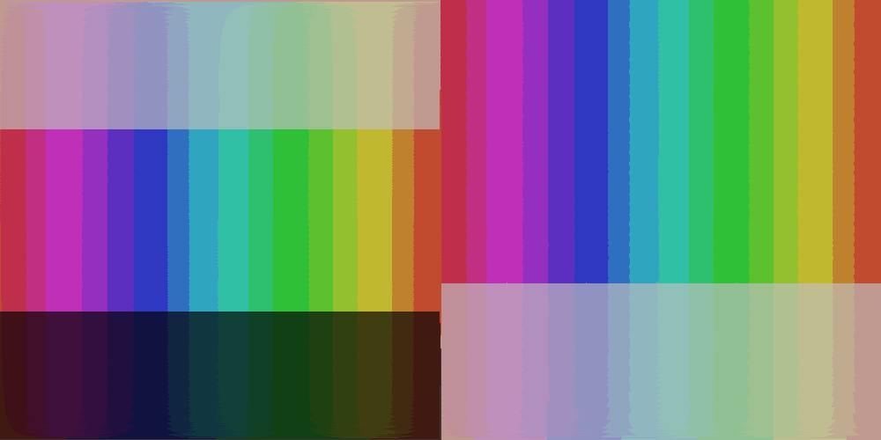  Ho_0_Sgp_100_So_0_Vgp_100_Vo_0_Enf_t_Hs_16_Ss_128_Vs_128_Fcb_t.bmp
Output description: This output uses the RGB-to-HSV flat-color path with flat-color enable set to true. Hue is quantized with step 16, saturation with step 128, and value/brightness with step 128. Flat-center binning is true, so each quantized bin is represented by its centered value when enabled. The visual result converts smooth gradients into discrete HSV color bands; larger steps create larger, flatter blocks, while smaller steps preserve more tonal detail.
Table 22. Settings Decoded from Generated Output 19 Filename
Setting | Data Type | Value Matched from Filename | Filename Token / Source
USE_FLAT_SEGMENT_PACKAGE | boolean | false | file prefix Ho
RGB_HSV_HUE_OFFSET | integer | false | Ho
RGB_HSV_SATURATION_GAIN_PERCENT | integer | 100 | Sgp
RGB_HSV_SATURATION_OFFSET | integer | false | So
RGB_HSV_VALUE_GAIN_PERCENT | integer | 100 | Vgp
RGB_HSV_VALUE_OFFSET | integer | false | Vo
RGB_HSV_ENABLE_FLAT_COLOR | boolean | true | Enf
RGB_HSV_HUE_STEP | integer | 16 | Hs
RGB_HSV_SATURATION_STEP | integer | 128 | Ss
RGB_HSV_VALUE_STEP | integer | 128 | Vs
RGB_HSV_FLAT_CENTER_BINS | boolean | true | Fcb

3.20 Output 20: Side-by-Side Visual Comparison
Generated Output Filename: Ho_0_Sgp_100_So_0_Vgp_100_Vo_0_Enf_t_Hs_32_Ss_64_Vs_85_Fcb_t.bmp | Mode: RGB-HSV Flat Color
Figure 20. Input Image Compared with Generated Output 20
Input Image | Generated Output Image
  1000_500.bmp | 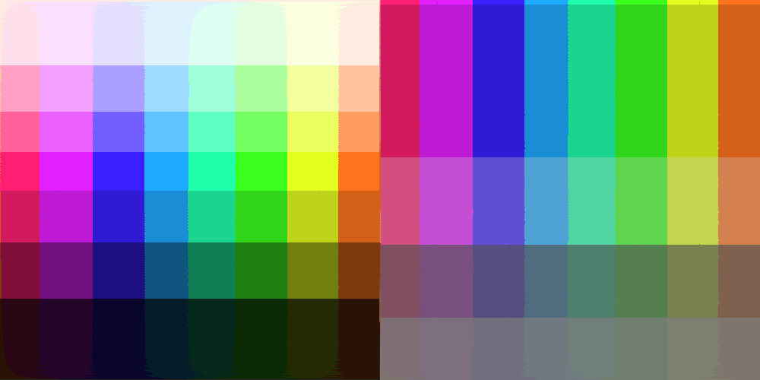  Ho_0_Sgp_100_So_0_Vgp_100_Vo_0_Enf_t_Hs_32_Ss_64_Vs_85_Fcb_t.bmp
Output description: This output uses the RGB-to-HSV flat-color path with flat-color enable set to true. Hue is quantized with step 32, saturation with step 64, and value/brightness with step 85. Flat-center binning is true, so each quantized bin is represented by its centered value when enabled. The visual result converts smooth gradients into discrete HSV color bands; larger steps create larger, flatter blocks, while smaller steps preserve more tonal detail.
Table 23. Settings Decoded from Generated Output 20 Filename
Setting | Data Type | Value Matched from Filename | Filename Token / Source
USE_FLAT_SEGMENT_PACKAGE | boolean | false | file prefix Ho
RGB_HSV_HUE_OFFSET | integer | false | Ho
RGB_HSV_SATURATION_GAIN_PERCENT | integer | 100 | Sgp
RGB_HSV_SATURATION_OFFSET | integer | false | So
RGB_HSV_VALUE_GAIN_PERCENT | integer | 100 | Vgp
RGB_HSV_VALUE_OFFSET | integer | false | Vo
RGB_HSV_ENABLE_FLAT_COLOR | boolean | true | Enf
RGB_HSV_HUE_STEP | integer | 32 | Hs
RGB_HSV_SATURATION_STEP | integer | 64 | Ss
RGB_HSV_VALUE_STEP | integer | 85 | Vs
RGB_HSV_FLAT_CENTER_BINS | boolean | true | Fcb

3.21 Output 21: Side-by-Side Visual Comparison
Generated Output Filename: Ho_0_Sgp_100_So_0_Vgp_100_Vo_0_Enf_t_Hs_32_Ss_128_Vs_128_Fcb_t.bmp | Mode: RGB-HSV Flat Color
Figure 21. Input Image Compared with Generated Output 21
Input Image | Generated Output Image
  1000_500.bmp | 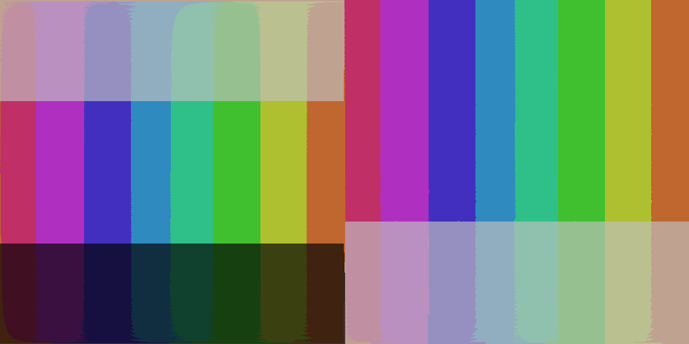  Ho_0_Sgp_100_So_0_Vgp_100_Vo_0_Enf_t_Hs_32_Ss_128_Vs_128_Fcb_t.bmp
Output description: This output uses the RGB-to-HSV flat-color path with flat-color enable set to true. Hue is quantized with step 32, saturation with step 128, and value/brightness with step 128. Flat-center binning is true, so each quantized bin is represented by its centered value when enabled. The visual result converts smooth gradients into discrete HSV color bands; larger steps create larger, flatter blocks, while smaller steps preserve more tonal detail.
Table 24. Settings Decoded from Generated Output 21 Filename
Setting | Data Type | Value Matched from Filename | Filename Token / Source
USE_FLAT_SEGMENT_PACKAGE | boolean | false | file prefix Ho
RGB_HSV_HUE_OFFSET | integer | false | Ho
RGB_HSV_SATURATION_GAIN_PERCENT | integer | 100 | Sgp
RGB_HSV_SATURATION_OFFSET | integer | false | So
RGB_HSV_VALUE_GAIN_PERCENT | integer | 100 | Vgp
RGB_HSV_VALUE_OFFSET | integer | false | Vo
RGB_HSV_ENABLE_FLAT_COLOR | boolean | true | Enf
RGB_HSV_HUE_STEP | integer | 32 | Hs
RGB_HSV_SATURATION_STEP | integer | 128 | Ss
RGB_HSV_VALUE_STEP | integer | 128 | Vs
RGB_HSV_FLAT_CENTER_BINS | boolean | true | Fcb

3.22 Output 22: Side-by-Side Visual Comparison
Generated Output Filename: Ho_0_Sgp_100_So_0_Vgp_100_Vo_0_Enf_t_Hs_64_Ss_128_Vs_128_Fcb_t.bmp | Mode: RGB-HSV Flat Color
Figure 22. Input Image Compared with Generated Output 22
Input Image | Generated Output Image
  1000_500.bmp |   Ho_0_Sgp_100_So_0_Vgp_100_Vo_0_Enf_t_Hs_64_Ss_128_Vs_128_Fcb_t.bmp
Output description: This output uses the RGB-to-HSV flat-color path with flat-color enable set to true. Hue is quantized with step 64, saturation with step 128, and value/brightness with step 128. Flat-center binning is true, so each quantized bin is represented by its centered value when enabled. The visual result converts smooth gradients into discrete HSV color bands; larger steps create larger, flatter blocks, while smaller steps preserve more tonal detail.
Table 25. Settings Decoded from Generated Output 22 Filename
Setting | Data Type | Value Matched from Filename | Filename Token / Source
USE_FLAT_SEGMENT_PACKAGE | boolean | false | file prefix Ho
RGB_HSV_HUE_OFFSET | integer | false | Ho
RGB_HSV_SATURATION_GAIN_PERCENT | integer | 100 | Sgp
RGB_HSV_SATURATION_OFFSET | integer | false | So
RGB_HSV_VALUE_GAIN_PERCENT | integer | 100 | Vgp
RGB_HSV_VALUE_OFFSET | integer | false | Vo
RGB_HSV_ENABLE_FLAT_COLOR | boolean | true | Enf
RGB_HSV_HUE_STEP | integer | 64 | Hs
RGB_HSV_SATURATION_STEP | integer | 128 | Ss
RGB_HSV_VALUE_STEP | integer | 128 | Vs
RGB_HSV_FLAT_CENTER_BINS | boolean | true | Fcb

3.23 Output 23: Side-by-Side Visual Comparison
Generated Output Filename: Ho_0_Sgp_100_So_0_Vgp_100_Vo_0_Enf_t_Hs_32_Ss_85_Vs_128_Fcb_t.bmp | Mode: RGB-HSV Flat Color
Figure 23. Input Image Compared with Generated Output 23
Input Image | Generated Output Image
  1000_500.bmp | 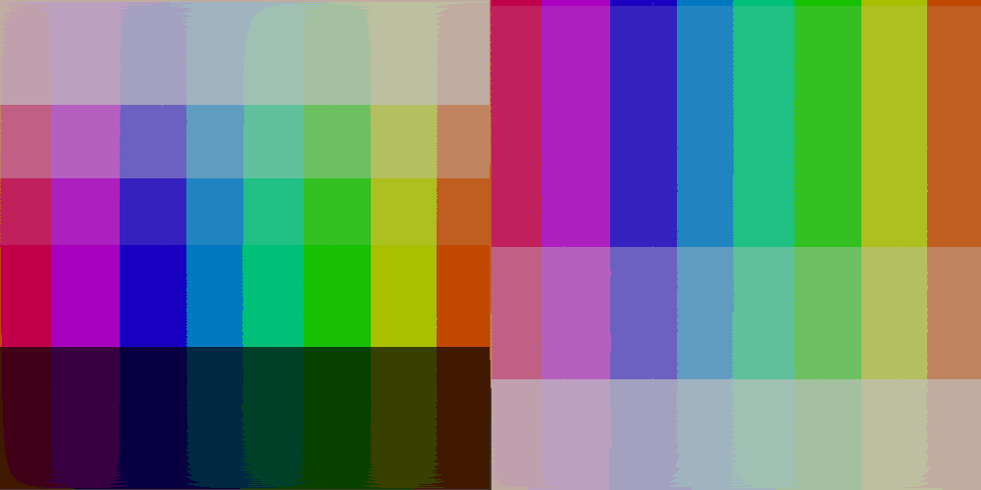  Ho_0_Sgp_100_So_0_Vgp_100_Vo_0_Enf_t_Hs_32_Ss_85_Vs_128_Fcb_t.bmp
Output description: This output uses the RGB-to-HSV flat-color path with flat-color enable set to true. Hue is quantized with step 32, saturation with step 85, and value/brightness with step 128. Flat-center binning is true, so each quantized bin is represented by its centered value when enabled. The visual result converts smooth gradients into discrete HSV color bands; larger steps create larger, flatter blocks, while smaller steps preserve more tonal detail.
Table 26. Settings Decoded from Generated Output 23 Filename
Setting | Data Type | Value Matched from Filename | Filename Token / Source
USE_FLAT_SEGMENT_PACKAGE | boolean | false | file prefix Ho
RGB_HSV_HUE_OFFSET | integer | false | Ho
RGB_HSV_SATURATION_GAIN_PERCENT | integer | 100 | Sgp
RGB_HSV_SATURATION_OFFSET | integer | false | So
RGB_HSV_VALUE_GAIN_PERCENT | integer | 100 | Vgp
RGB_HSV_VALUE_OFFSET | integer | false | Vo
RGB_HSV_ENABLE_FLAT_COLOR | boolean | true | Enf
RGB_HSV_HUE_STEP | integer | 32 | Hs
RGB_HSV_SATURATION_STEP | integer | 85 | Ss
RGB_HSV_VALUE_STEP | integer | 128 | Vs
RGB_HSV_FLAT_CENTER_BINS | boolean | true | Fcb

3.24 Output 24: Side-by-Side Visual Comparison
Generated Output Filename: Ho_0_Sgp_100_So_0_Vgp_100_Vo_0_Enf_t_Hs_32_Ss_42_Vs_128_Fcb_t.bmp | Mode: RGB-HSV Flat Color
Figure 24. Input Image Compared with Generated Output 24
Input Image | Generated Output Image
  1000_500.bmp | 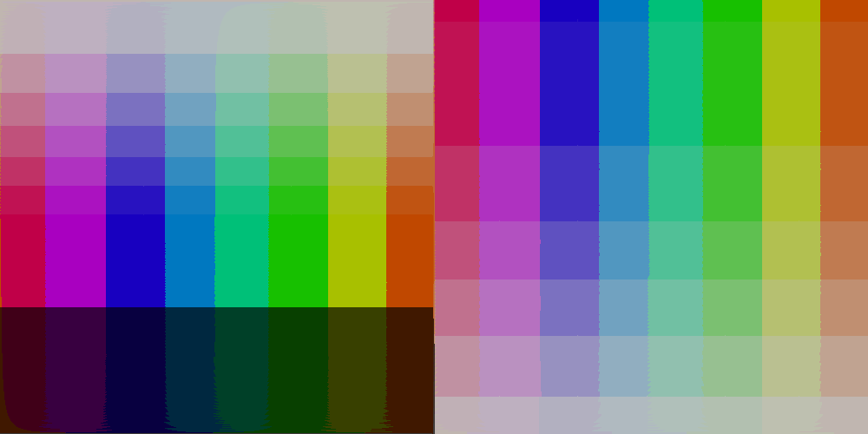  Ho_0_Sgp_100_So_0_Vgp_100_Vo_0_Enf_t_Hs_32_Ss_42_Vs_128_Fcb_t.bmp
Output description: This output uses the RGB-to-HSV flat-color path with flat-color enable set to true. Hue is quantized with step 32, saturation with step 42, and value/brightness with step 128. Flat-center binning is true, so each quantized bin is represented by its centered value when enabled. The visual result converts smooth gradients into discrete HSV color bands; larger steps create larger, flatter blocks, while smaller steps preserve more tonal detail.
Table 27. Settings Decoded from Generated Output 24 Filename
Setting | Data Type | Value Matched from Filename | Filename Token / Source
USE_FLAT_SEGMENT_PACKAGE | boolean | false | file prefix Ho
RGB_HSV_HUE_OFFSET | integer | false | Ho
RGB_HSV_SATURATION_GAIN_PERCENT | integer | 100 | Sgp
RGB_HSV_SATURATION_OFFSET | integer | false | So
RGB_HSV_VALUE_GAIN_PERCENT | integer | 100 | Vgp
RGB_HSV_VALUE_OFFSET | integer | false | Vo
RGB_HSV_ENABLE_FLAT_COLOR | boolean | true | Enf
RGB_HSV_HUE_STEP | integer | 32 | Hs
RGB_HSV_SATURATION_STEP | integer | 42 | Ss
RGB_HSV_VALUE_STEP | integer | 128 | Vs
RGB_HSV_FLAT_CENTER_BINS | boolean | true | Fcb

3.25 Output 25: Side-by-Side Visual Comparison
Generated Output Filename: Ho_0_Sgp_100_So_0_Vgp_100_Vo_0_Enf_t_Hs_32_Ss_85_Vs_85_Fcb_t.bmp | Mode: RGB-HSV Flat Color
Figure 25. Input Image Compared with Generated Output 25
Input Image | Generated Output Image
  1000_500.bmp | 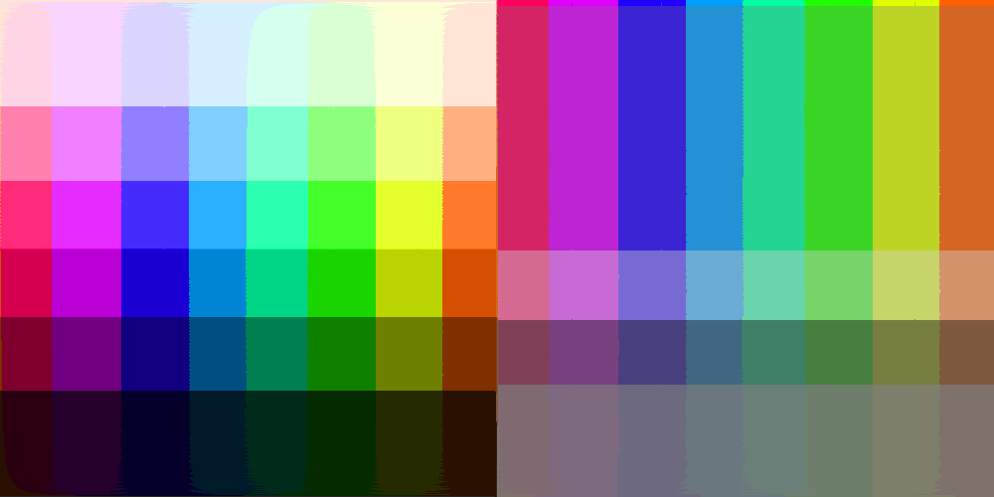  Ho_0_Sgp_100_So_0_Vgp_100_Vo_0_Enf_t_Hs_32_Ss_85_Vs_85_Fcb_t.bmp
Output description: This output uses the RGB-to-HSV flat-color path with flat-color enable set to true. Hue is quantized with step 32, saturation with step 85, and value/brightness with step 85. Flat-center binning is true, so each quantized bin is represented by its centered value when enabled. The visual result converts smooth gradients into discrete HSV color bands; larger steps create larger, flatter blocks, while smaller steps preserve more tonal detail.
Table 28. Settings Decoded from Generated Output 25 Filename
Setting | Data Type | Value Matched from Filename | Filename Token / Source
USE_FLAT_SEGMENT_PACKAGE | boolean | false | file prefix Ho
RGB_HSV_HUE_OFFSET | integer | false | Ho
RGB_HSV_SATURATION_GAIN_PERCENT | integer | 100 | Sgp
RGB_HSV_SATURATION_OFFSET | integer | false | So
RGB_HSV_VALUE_GAIN_PERCENT | integer | 100 | Vgp
RGB_HSV_VALUE_OFFSET | integer | false | Vo
RGB_HSV_ENABLE_FLAT_COLOR | boolean | true | Enf
RGB_HSV_HUE_STEP | integer | 32 | Hs
RGB_HSV_SATURATION_STEP | integer | 85 | Ss
RGB_HSV_VALUE_STEP | integer | 85 | Vs
RGB_HSV_FLAT_CENTER_BINS | boolean | true | Fcb

3.26 Output 26: Side-by-Side Visual Comparison
Generated Output Filename: Ho_0_Sgp_100_So_0_Vgp_100_Vo_0_Enf_t_Hs_32_Ss_85_Vs_120_Fcb_t.bmp | Mode: RGB-HSV Flat Color
Figure 26. Input Image Compared with Generated Output 26
Input Image | Generated Output Image
  1000_500.bmp | 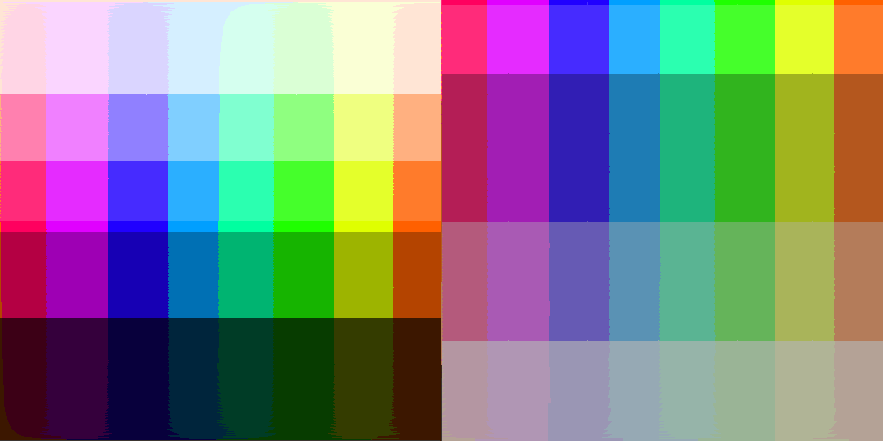  Ho_0_Sgp_100_So_0_Vgp_100_Vo_0_Enf_t_Hs_32_Ss_85_Vs_120_Fcb_t.bmp
Output description: This output uses the RGB-to-HSV flat-color path with flat-color enable set to true. Hue is quantized with step 32, saturation with step 85, and value/brightness with step 120. Flat-center binning is true, so each quantized bin is represented by its centered value when enabled. The visual result converts smooth gradients into discrete HSV color bands; larger steps create larger, flatter blocks, while smaller steps preserve more tonal detail.
Table 29. Settings Decoded from Generated Output 26 Filename
Setting | Data Type | Value Matched from Filename | Filename Token / Source
USE_FLAT_SEGMENT_PACKAGE | boolean | false | file prefix Ho
RGB_HSV_HUE_OFFSET | integer | false | Ho
RGB_HSV_SATURATION_GAIN_PERCENT | integer | 100 | Sgp
RGB_HSV_SATURATION_OFFSET | integer | false | So
RGB_HSV_VALUE_GAIN_PERCENT | integer | 100 | Vgp
RGB_HSV_VALUE_OFFSET | integer | false | Vo
RGB_HSV_ENABLE_FLAT_COLOR | boolean | true | Enf
RGB_HSV_HUE_STEP | integer | 32 | Hs
RGB_HSV_SATURATION_STEP | integer | 85 | Ss
RGB_HSV_VALUE_STEP | integer | 120 | Vs
RGB_HSV_FLAT_CENTER_BINS | boolean | true | Fcb

3.27 Output 27: Side-by-Side Visual Comparison
Generated Output Filename: Ho_0_Sgp_100_So_0_Vgp_100_Vo_0_Enf_t_Hs_32_Ss_120_Vs_43_Fcb_t.bmp | Mode: RGB-HSV Flat Color
Figure 27. Input Image Compared with Generated Output 27
Input Image | Generated Output Image
  1000_500.bmp | 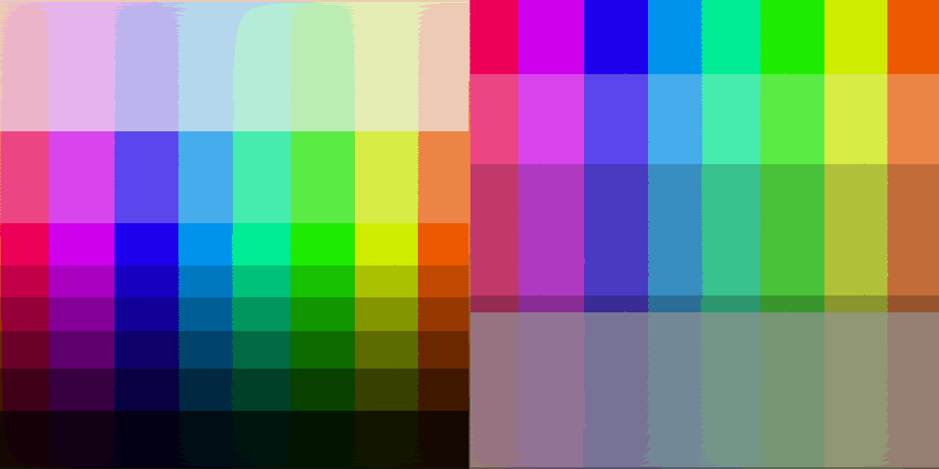  Ho_0_Sgp_100_So_0_Vgp_100_Vo_0_Enf_t_Hs_32_Ss_120_Vs_43_Fcb_t.bmp
Output description: This output uses the RGB-to-HSV flat-color path with flat-color enable set to true. Hue is quantized with step 32, saturation with step 120, and value/brightness with step 43. Flat-center binning is true, so each quantized bin is represented by its centered value when enabled. The visual result converts smooth gradients into discrete HSV color bands; larger steps create larger, flatter blocks, while smaller steps preserve more tonal detail.
Table 30. Settings Decoded from Generated Output 27 Filename
Setting | Data Type | Value Matched from Filename | Filename Token / Source
USE_FLAT_SEGMENT_PACKAGE | boolean | false | file prefix Ho
RGB_HSV_HUE_OFFSET | integer | false | Ho
RGB_HSV_SATURATION_GAIN_PERCENT | integer | 100 | Sgp
RGB_HSV_SATURATION_OFFSET | integer | false | So
RGB_HSV_VALUE_GAIN_PERCENT | integer | 100 | Vgp
RGB_HSV_VALUE_OFFSET | integer | false | Vo
RGB_HSV_ENABLE_FLAT_COLOR | boolean | true | Enf
RGB_HSV_HUE_STEP | integer | 32 | Hs
RGB_HSV_SATURATION_STEP | integer | 120 | Ss
RGB_HSV_VALUE_STEP | integer | 43 | Vs
RGB_HSV_FLAT_CENTER_BINS | boolean | true | Fcb

3.28 Output 28: Side-by-Side Visual Comparison
Generated Output Filename: Ho_0_Sgp_100_So_0_Vgp_100_Vo_0_Enf_t_Hs_32_Ss_120_Vs_85_Fcb_t.bmp | Mode: RGB-HSV Flat Color
Figure 28. Input Image Compared with Generated Output 28
Input Image | Generated Output Image
  1000_500.bmp | 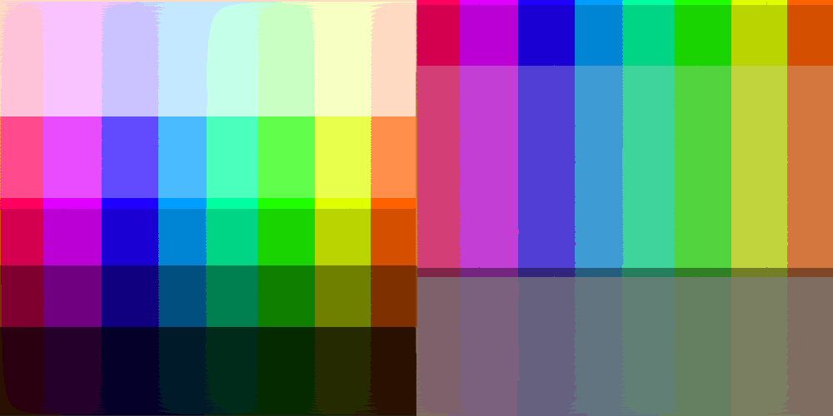  Ho_0_Sgp_100_So_0_Vgp_100_Vo_0_Enf_t_Hs_32_Ss_120_Vs_85_Fcb_t.bmp
Output description: This output uses the RGB-to-HSV flat-color path with flat-color enable set to true. Hue is quantized with step 32, saturation with step 120, and value/brightness with step 85. Flat-center binning is true, so each quantized bin is represented by its centered value when enabled. The visual result converts smooth gradients into discrete HSV color bands; larger steps create larger, flatter blocks, while smaller steps preserve more tonal detail.
Table 31. Settings Decoded from Generated Output 28 Filename
Setting | Data Type | Value Matched from Filename | Filename Token / Source
USE_FLAT_SEGMENT_PACKAGE | boolean | false | file prefix Ho
RGB_HSV_HUE_OFFSET | integer | false | Ho
RGB_HSV_SATURATION_GAIN_PERCENT | integer | 100 | Sgp
RGB_HSV_SATURATION_OFFSET | integer | false | So
RGB_HSV_VALUE_GAIN_PERCENT | integer | 100 | Vgp
RGB_HSV_VALUE_OFFSET | integer | false | Vo
RGB_HSV_ENABLE_FLAT_COLOR | boolean | true | Enf
RGB_HSV_HUE_STEP | integer | 32 | Hs
RGB_HSV_SATURATION_STEP | integer | 120 | Ss
RGB_HSV_VALUE_STEP | integer | 85 | Vs
RGB_HSV_FLAT_CENTER_BINS | boolean | true | Fcb

